INFO-B 636 Assignment 2
Matthew Ng
Report
After featureCounts, the output files were moved to RStudio for differential gene expression analysis via DESeq2. GO enrichment analysis was performed thereafter.
The threshold values used for the DESeq2 analysis were padj < 0.05 and abs(log2FoldChange) >= 1. Based on these values, the number of DEGs between Mock vs SARS-CoV2 was 48. The number of DEGs between 24H vs 72H was 142.
The GO enrichment analysis resulted in two csv files where each row contains an enriched GO term in the ontology. The columns contain information such as GO ID, description, gene counts, p-values, adjusted p-values, and gene lists. The csv files will be submitted along with the rest of the required files. The analysis also generated two dot plots for each of the comparisons.
Figure 1: 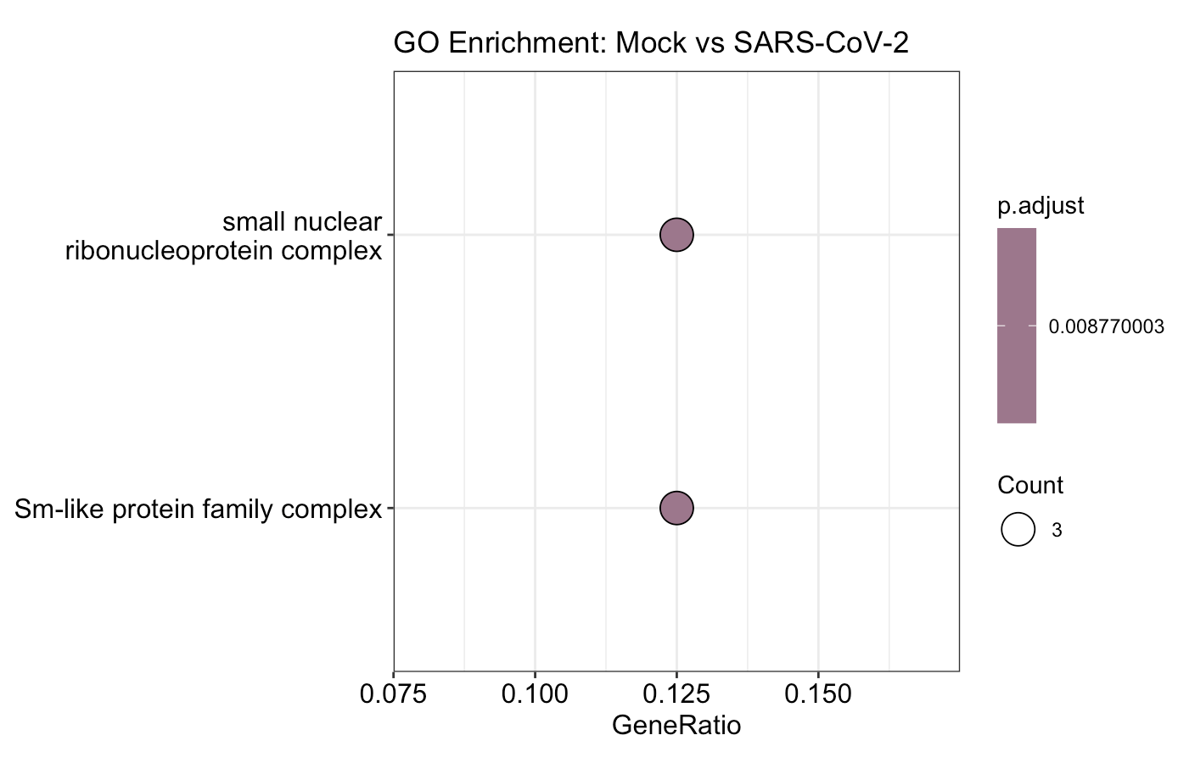

Figure 2:
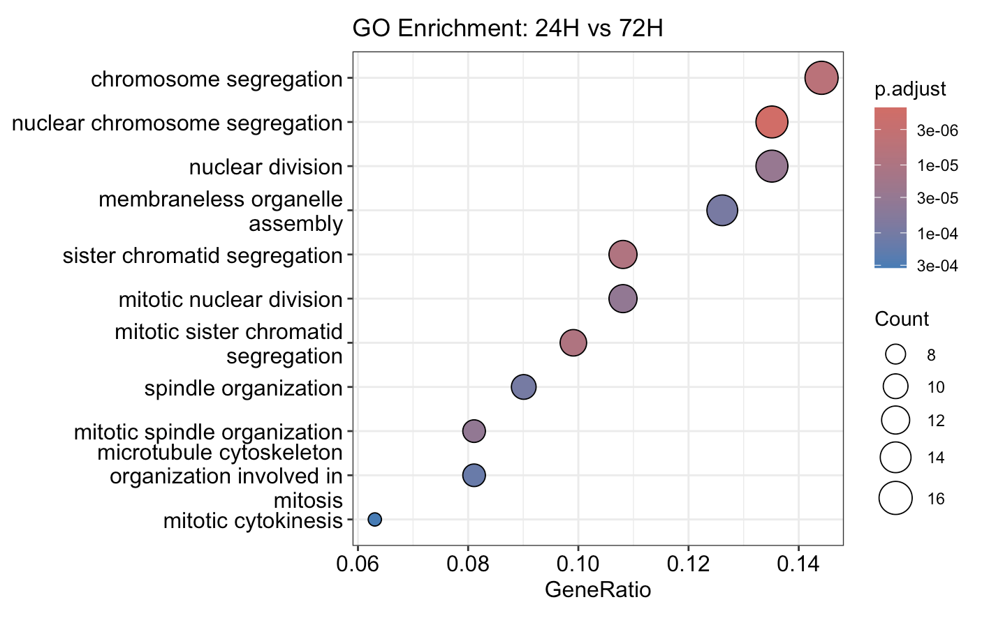
These two figures visualize the top GO terms by enrichment. Figure 1 is the output of Mock vs SARS-CoV2 based on cellular component ontology while Figure 2 is the output of 24H vs 72H based on biological processes ontology.

